Mallu Sravana Sandhya Assessment-13 18/12/23

Oops:Aims to implement real world entities

Class and objects are used for implementing oops concept

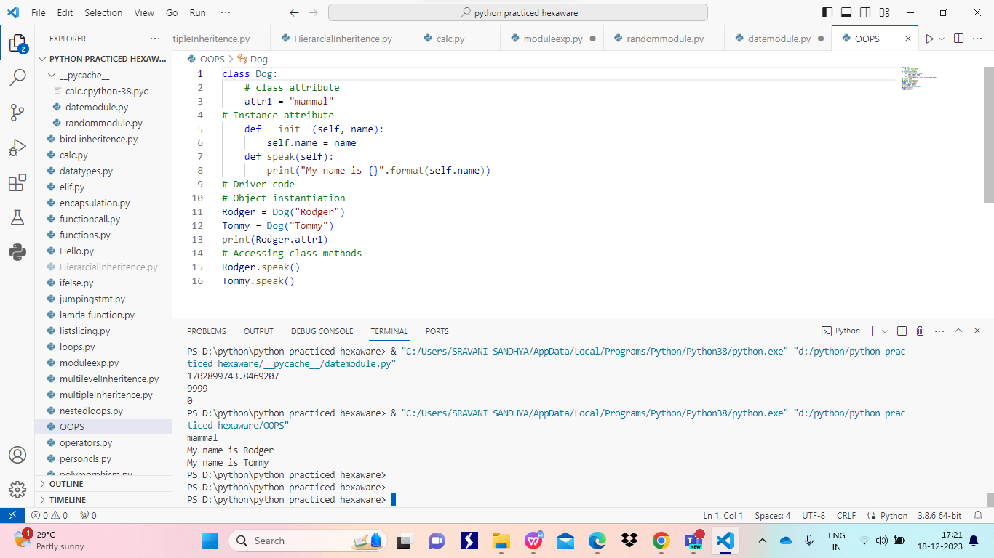

Person class with inheritence and overloading

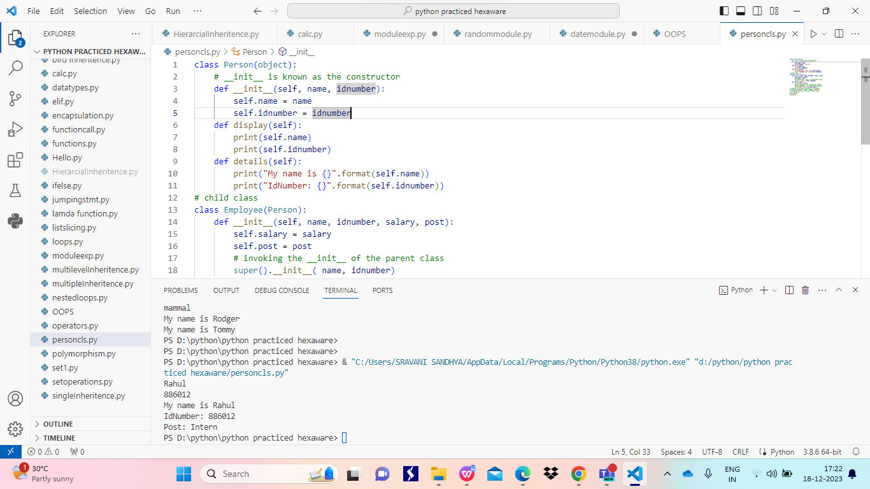

Bird inheritence

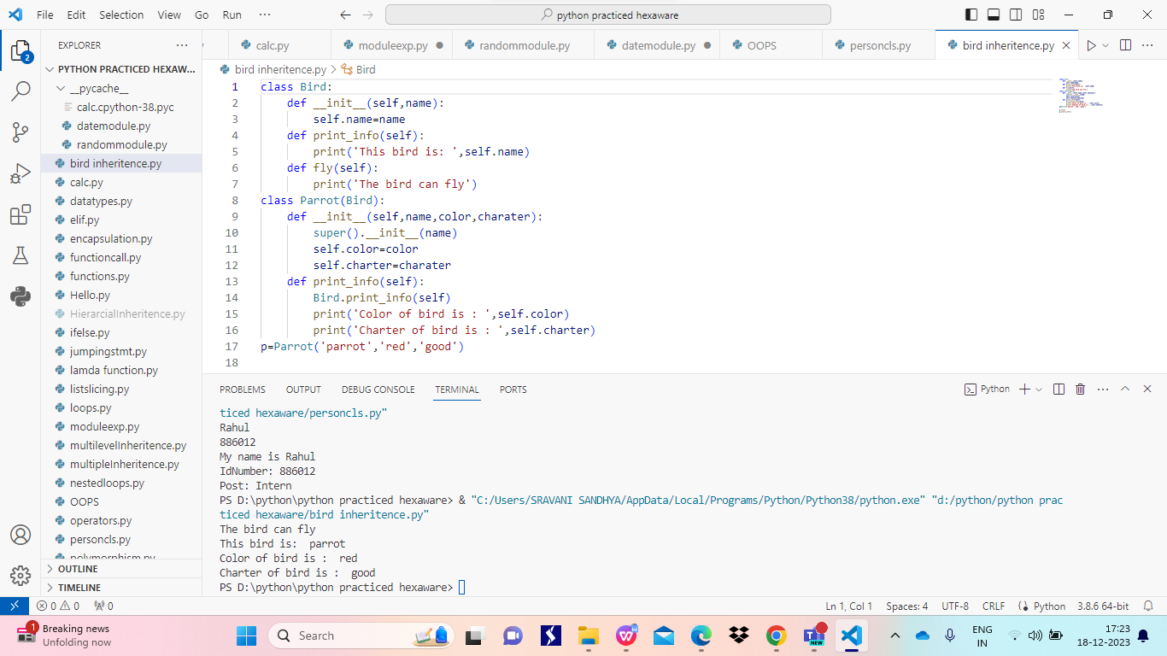

Polymorphism-having many forms

Code demonstrates inheritence and method overriding

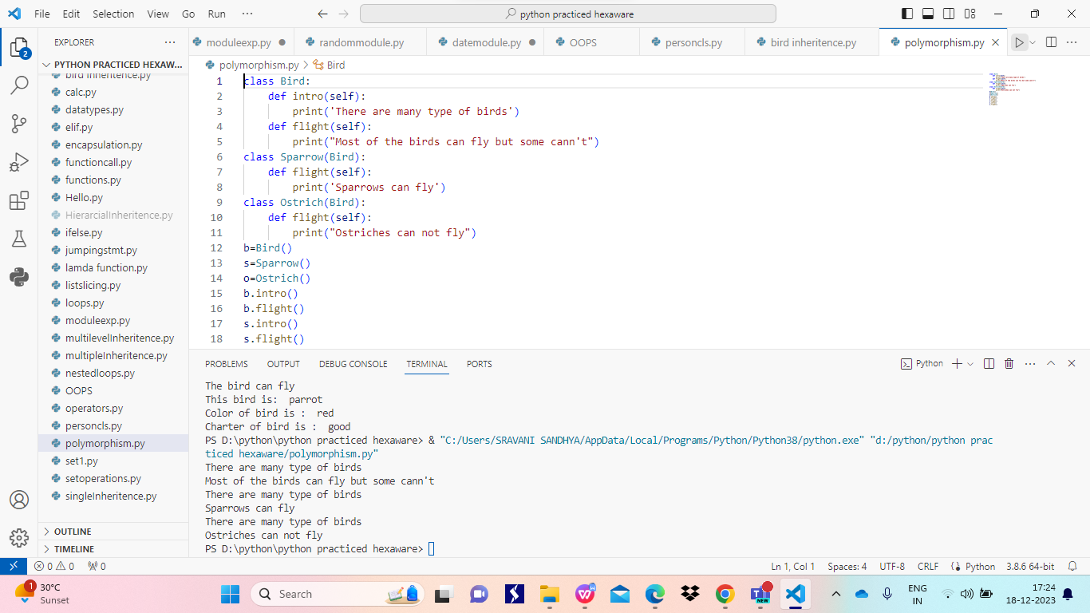

Encapsulation: idea of wraping of data and methods that work on data with in one unit

It puts restrictions on accessing data directly which helps to prevent modifications in the code

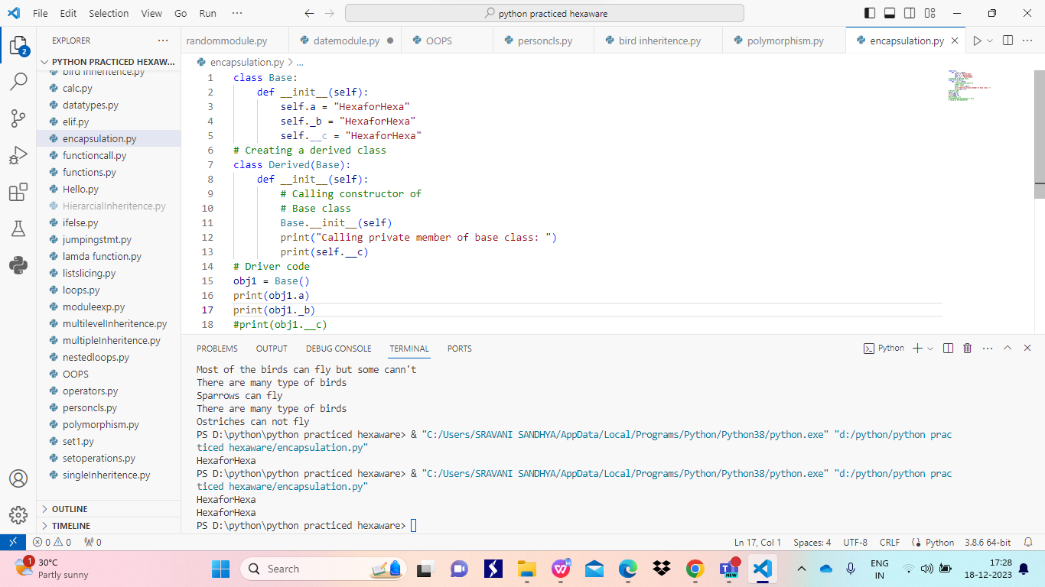

Inheritence: the property of deriving the attributes and methods from one or more classes

Super/parent/base class: the class from which the properties are derived

Sub/child/derived class: the class which derives properties from other classes

Single inheritence: in which child class derives properties from only one class

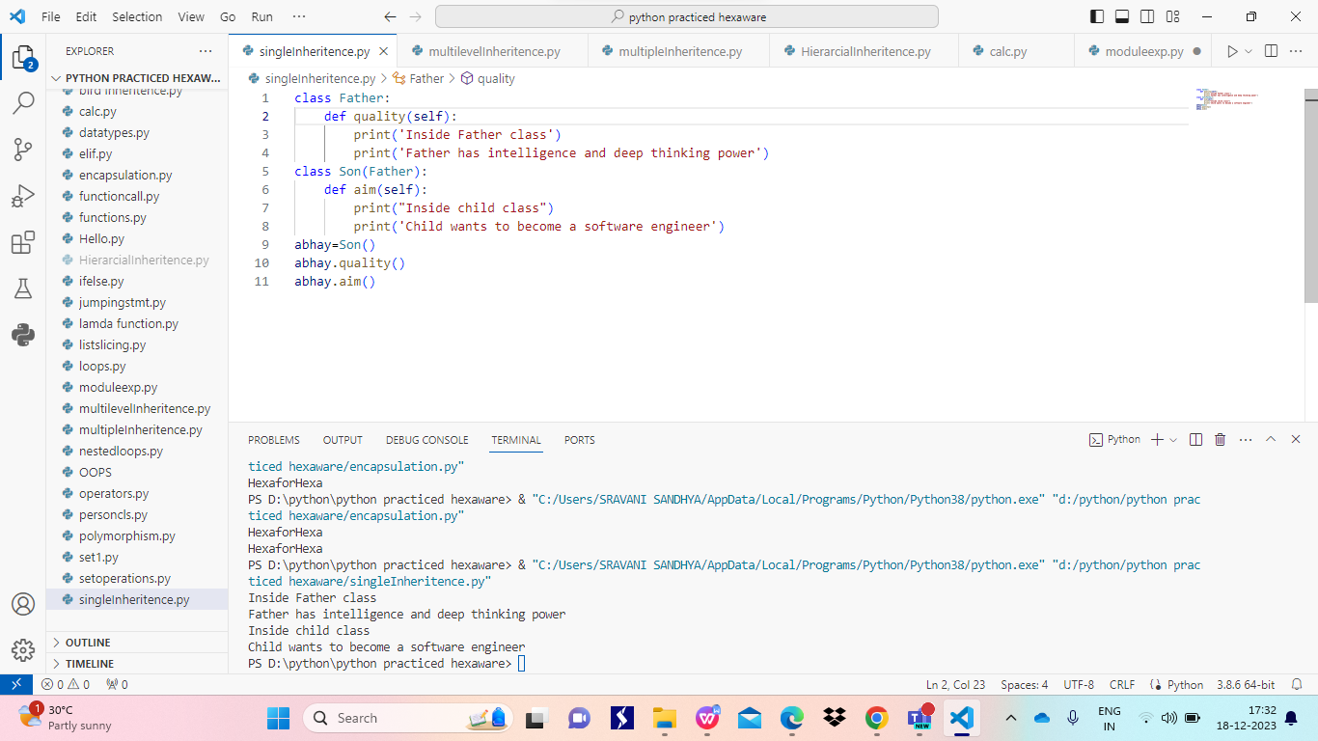

Multilevel inheritence: in which the derived class properties are derived by another sub class

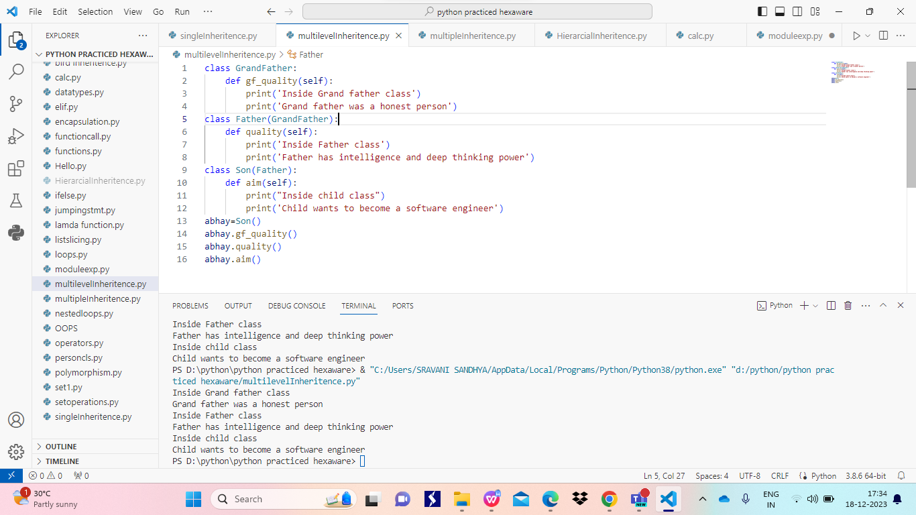

Multiple inheritence: in which a sub class derives its properties from more than one class

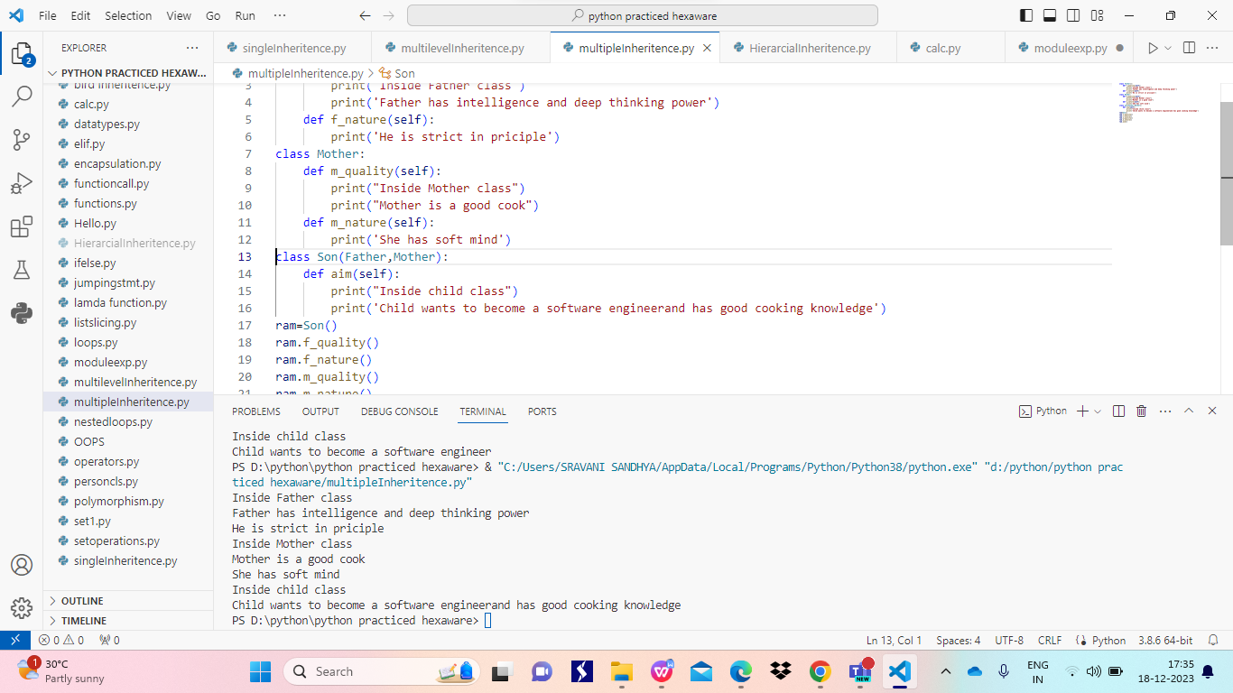

Hirearcial inheritence :in which one parent class properties are derived by more than one sub classes

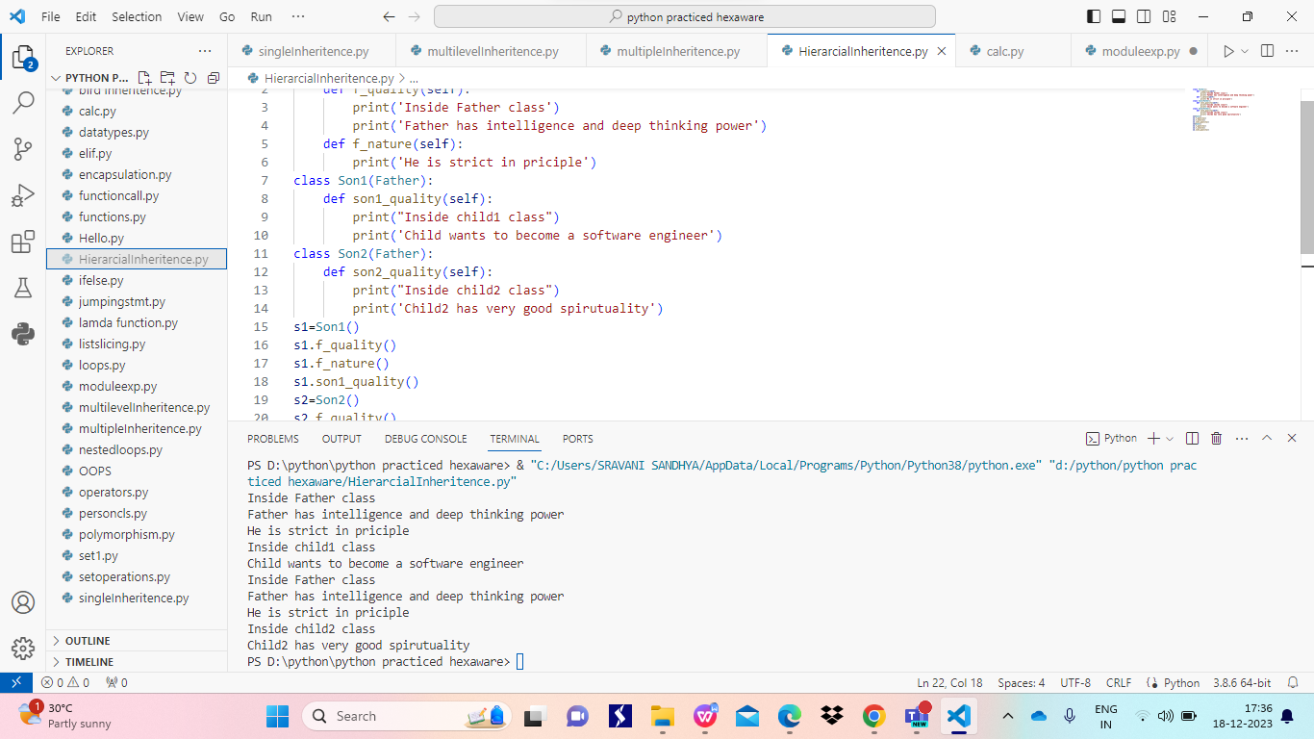

Modules: module is a file which defines definations,variables and functions

It can be imported using import keyword or using from and import at a time

Syntax:

Import module_name

From module_name import object_name

Clac.py is created as module

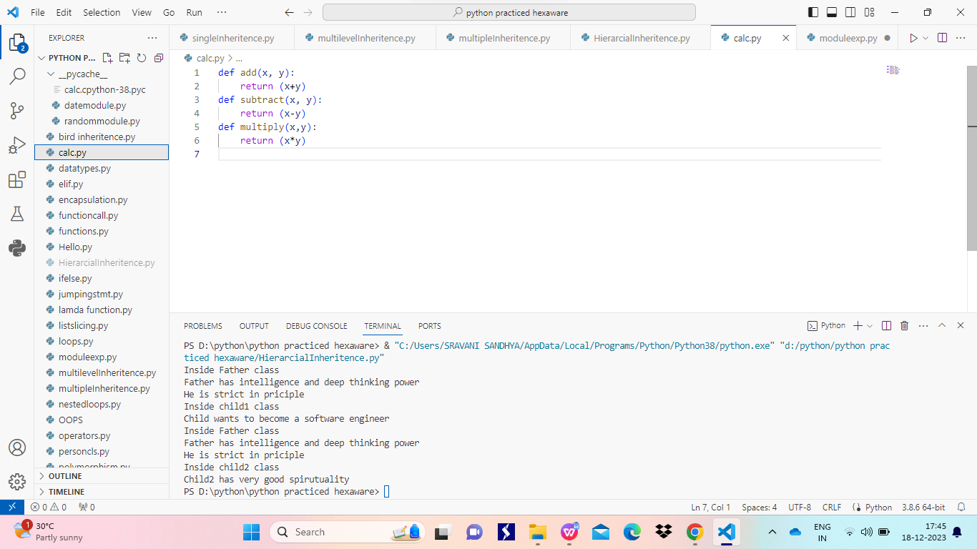

IN OTHER file we imported the calc module and performed the methods with in the module

Also used math module in the same file

We can rename the module using as keyword

Syntax:

Import module_name as m

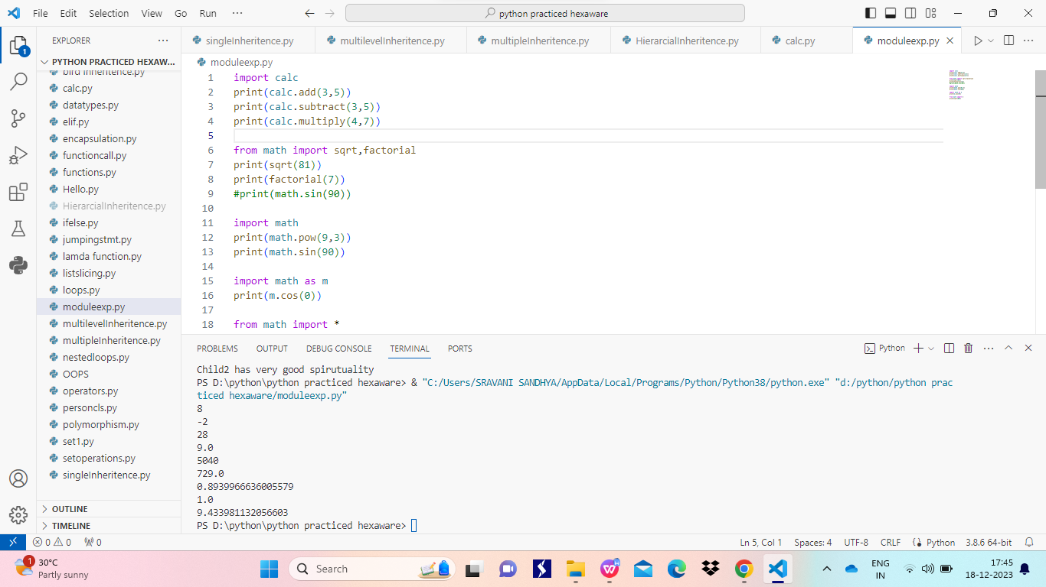

Using random module

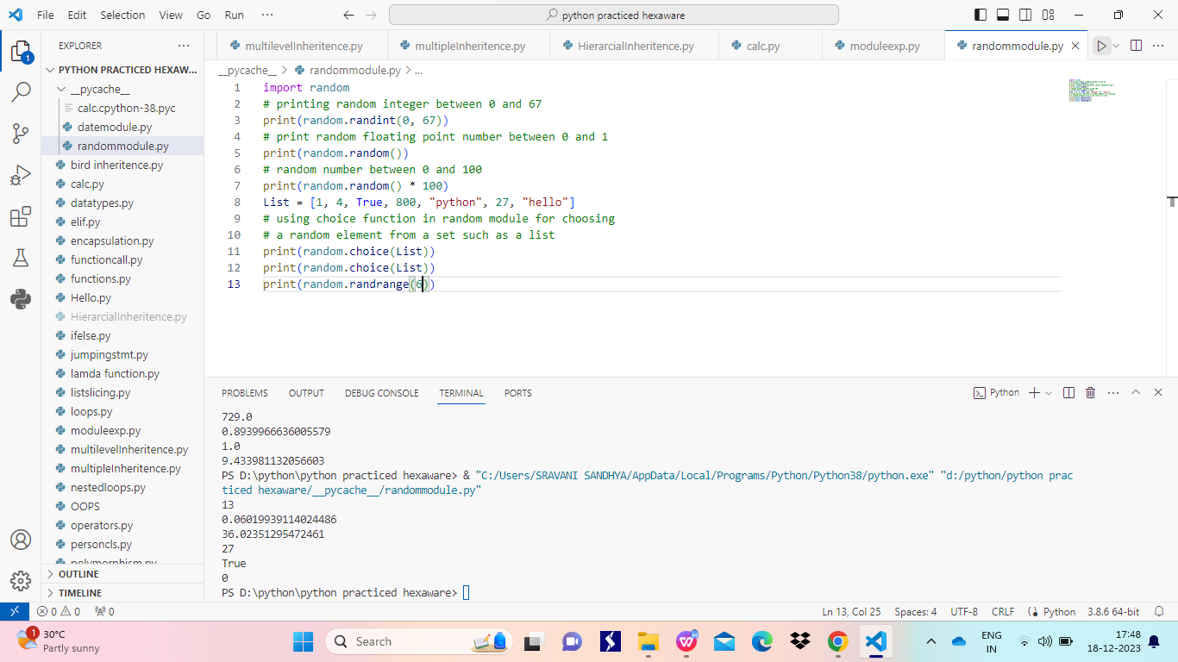

Using datetime module

